# **EXPERMINET.N0.2**

# **Objective: -** Execution of Unix General Purpose Utility Commands

**Outcome:** Identify the Unix general purpose commands

# **General purpose Commands** - echo, clear, exit, date, time, uptime, cal, cat, tty, man, which, history, id, pwd, whoami, ping, ifconfig, pr.Working with Editor Vi/other editor

**Exercise 1 (Getting Familiar with Linux)**

Enter these commands at the UNIX prompt, and try to interpret the output:

* echo hello world



* date



* who am i



* who



* echo $SHELL



* time sleep



* history

**Exercise 2 Execute following set of commands in sequence**

* cd
* ls  
  Text

  Description automatically generated
* pwd



* cd ..



* ls –al | more

1. Change back into your home directory.



1. Make subdirectories called **work** and **play.**



1. Delete subdirectory called **work.**

1. Copy file /etc/passwd into your home directory.

1. Move it into the subdirectory **play**

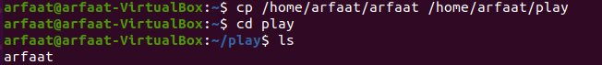

The most popular editor under unix environment is vi editor, a visual editor. It supports most programming languages and their syntax. This will be in three modes:

1. Command mode: The default mode where every key pressed is interpreted as command.
2. Input mode: This mode allows us type in the text.
3. ex mode (or last line mode): This mode is used to handle files.

To create or modify a text file, type *vi filename <enter>* at the shell prompt.

Example: …]$ vi hello.c

# **Conclusion:-** General purpose commands executed successfully.